Explain Life cycle in Class Component and functional component with Hooks

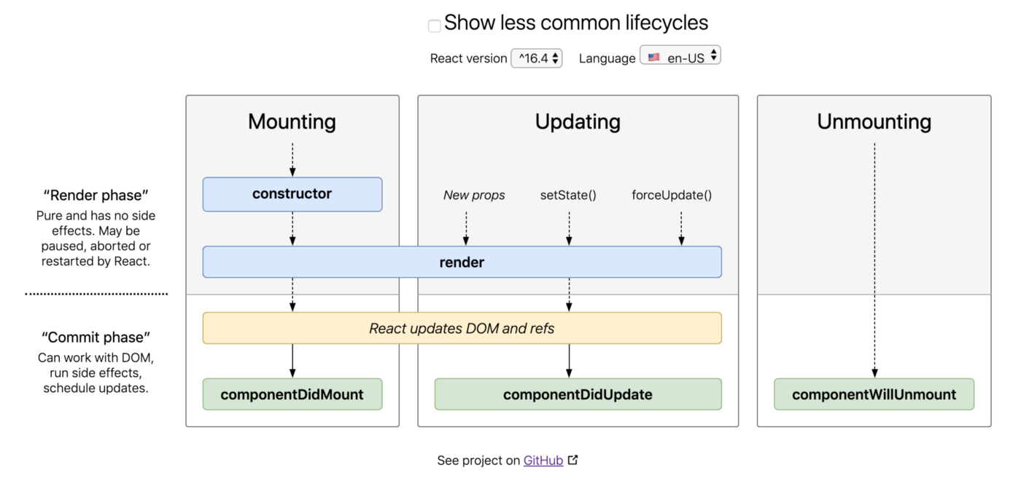**Class Component**

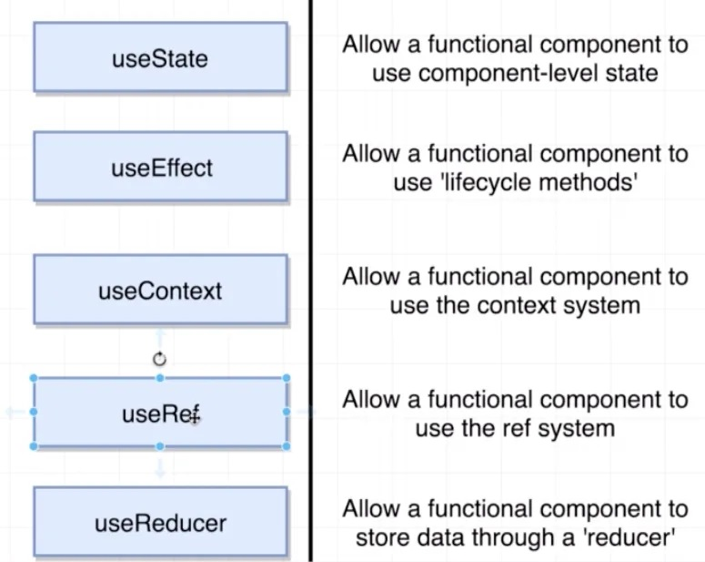**functional component with Hooks**